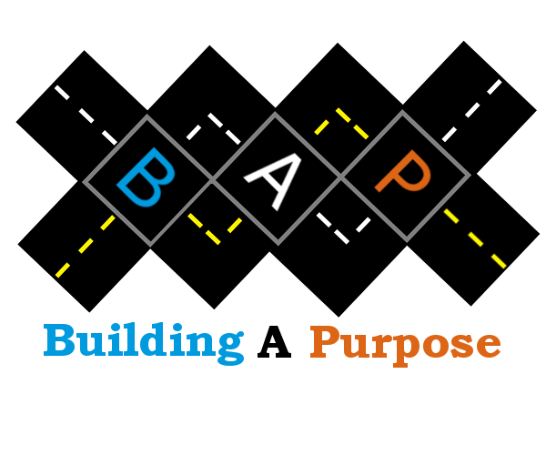
Thank you for considering a partnership with Building A Purpose, an organization focused on helping students build the road towards higher education. Each year dozens of students go through mentorship and free SAT and scholarship workshops with Building A Purpose (BAP). Throughout 2019 BAP will connect dozens of students from around San Antonio with professionals in career fields that spark their interest to start the road ahead.

When my wife and I first founded the organization in 2015 we knew this would not be an easy task. Tackling the reality of "living life by default" would take generous resources and a great number of different professionals who share their experiences with students in the hope that they will explore the multitude of careers available to them, and with this live life on purpose.

Our students come from all walks of life, and as you may know, the road to success is a long winding one. Without supporters like you, we would not be able to provide the mentorship and essential programs that we do. We are proud of the quality programming and preparation we provide for our youth. We're even prouder to tell these kids that they have the support of BAP and their community. People like you are bringing them the gift of opportunity knowing that they truly are our hope for the future. Your support helps our students overcome obstacles stacked against them to become professionals in the field of their choice.

Thank you for what you do and thank you for your support.

Let's Start Building!

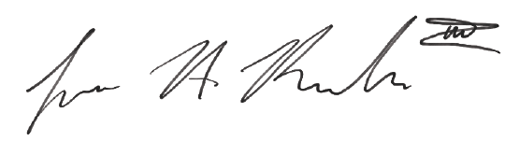
Jesus Antonio Rendon III
Co-Founder

Building A Purpose Benefit Dinner
Henry B. González Convention Center
October 1st, 2022; Doors open @ 6:00pm - 10:00pm

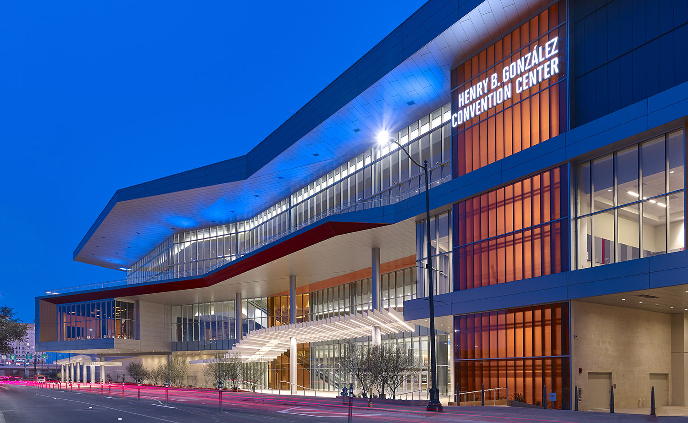

BELIEVE IN YOU SPONSOR: $25,000
- Featured Sponsorship video focused on Sponsor and their support
- Five-minute speaking opportunity during event remarks
- Distinct Verbal Recognition at Dinner
- Premier Logo Placement on all Collateral Including Website and Advertising
- Name Recognition on list of sponsors in the Program
- Two (2) Reserved Sponsor Tables of eight (8) in a premiere location with sponsorship recognition
- Premier Logo Placement in Picture backdrop

PURPOSE SPONSOR: $10,000

- Three - minute speaking opportunity during remarks
- Distinct Verbal Recognition at Dinner
- Premier Logo Placement on all Collateral Including Website and Advertising
- Name Recognition on list of sponsors in the Program
- Two (2) Reserved Sponsor Tables of eight (8) in a premiere location with sponsorship recognition
- Logo Placement in Picture backdrop

BE SPONSOR: $5,000

- Verbal Recognition at Dinner
- Premier Logo Placement on all Collateral Including Website and Advertising
- Name Recognition on list of sponsors in the Program
- One (1) Reserved Sponsor Tables of eight (8) in a premiere location with sponsorship recognition
- Logo Placement in Picture backdrop

BUILD SPONSOR: $2,500

- Premier Logo Placement on all Collateral Including Website and Advertising
- Name Recognition on list of sponsors in the Program
- One (1) Reserved Sponsor Tables of eight (8) in a premiere location with sponsorship recognition
- Logo Placement in Picture backdrop

CHOOSE SPONSOR: $1,750

- Name Recognition on list of sponsors in the Program
- One (1) Reserved Sponsor Tables of eight (8) in a premiere location with sponsorship recognition
- Logo Placement in Picture backdrop

